MoodSwing Development in 27 Days

Deadline for Round 2 submission is April 27, 2011, 23:59 GMT. Here are some things to think about and do for the next 27 days.

How to use this document: highlight updates in yellow. Once you’ve read an update, add your name to the end of the block that was highlighted. The last person to read the update will un-highlight the block. Update by: Vern, Read by: Vern, J

# The Code

## Pedestrian Simulation

Jans can probably improve the pedestrian simulation. I've found nice XNA 4 samples for aiming, chase and evade, and flocking. Most of the code can be copied – their authors have allowed anyone to copy and use the code in games.

Sample code for aiming:

<http://create.msdn.com/en-US/education/catalog/sample/aiming>

Sample code for chase and evade:

<http://create.msdn.com/en-US/education/catalog/sample/chase_evade>

Sample code for flocking:

<http://create.msdn.com/en-US/education/catalog/sample/flocking>

Okay, so what exactly needs to be changed in terms of behavior? I suggest the following. You may add more suggestions and react violently against what I've put here.

1. Citizens have to enter and exit through the doors of the buildings, not just the side of the buildings where the doors are.

Suggested solution: Create an extra vector representing where the door of a building is relative to the building, so that citizens don't have to come from or target the center of the building, just the door.

*Correct me if I’m wrong, but we decided to make all sides passable now right? (same as the earlier versions of game) If so, it is done. Update: J, Read: J

1. Citizens have to turn properly. Since we're going to do away with spherical people eventually, they have to know how to turn.

Suggested solution: See the code sample on aiming. (Actually, I don't think Jans needs this code sample as it's pretty straightforward. No pun intended here.)

1. Citizens have to stop bumping building corners (not really important). Citizens have to stop bumping each other (more important – seriously, it’s just wrong).

Suggested solution: I have no idea how to do this yet.

1. Mobs will have to move as a whole.

Suggested solution: See the code sample on flocking and try to apply the ideas there.

1. Instead of stopping, mobbing people will ideally continue mobbing even if the towers have already detected them. They’ll only stop once they’ve been chased and caught. Volunteers will have to walk faster than the mobbing people though. The only issue I see here is that there’s a possibility that volunteers will chase the mobbing people through the district hall. Once there’s a head-on encounter, both units should face each other (to simulate “talking”) before heading back to the tower. It also need not be the case that only one person will face and listen to the volunteer, because realistically, a volunteer may attract more than one person’s attention, but this makes the implementation a lot more complicated and unless we can do it fairly quickly, we might not be worrying about that too much.

Suggested solution: See the code sample on chasing. On the issue of chasing through the district hall, the volunteer can chase an actual citizen instead of just chasing a vector, and once the citizen is gone, the volunteer returns to the tower and if it encounters any other possible targets, “chases” it again. (I put *chases* in quotes since the chasing would be virtually not present if it’s a head-on encounter.)

1. Oh, guys, fix this too… the tile count for the range of the towers must start from the side where the door is, because otherwise, volunteers may chase mobbers that are near the tower but actually far when walking. [Fixed, I think] Update By: marktan, Read by: marktan, Vern, J

## Options Screen

I can handle this part.

## Support for Multiple Districts and Story

Support for multiple districts shouldn’t take that long to implement. Support for story is a little trickier. The approach we agreed upon was to embed the story into the district. The easier (and less innovative, blander) approach would be to have a small comic strip at the beginning of each district, but this sucks because it’s too cliché and would mean that multiple future visits to the same district will not have any interesting things tied to it. That is, we can actually make more stories if we do away with comics. Of course, there’s nothing stopping us from doing both if you think that would be nicer. Mark can handle the multiple districts part and I can probably handle the story part.

## Extra UI Animations

Some animations that we planned to implement with the circular picker weren’t finished in the first round. I can handle this part.

## Saved Games and Profiles

Nothing much to say here, except that the profile picker might be a pain in the ass to implement. This has to be implemented a bit later than the other features.

# The Gameplay

## Tower Hierarchies and Upgrades

This is something that will need a lot of our attention. Needless to say, more versions of the circular picker will be needed for this. The preferred arrangement of upgrades as of the moment is generic to specific. For example, a hospital can address 3 MDG’s: child health, maternal health, and widespread malaria. Upgrading will then allow it to specialize. Alternatively, a hospital can be specific at the start and upgrades will allow it to tackle more MDG’s. For example, a children’s clinic can be upgraded into a family clinic, which can be upgraded into a general hospital, and so on. I need your opinions on this.

## General Help Centers

If we are to implement this, some significant amount of revamping will need to be done on the circular picker. Also, we can do away with the rule that complaints start occurring one MDG at a time. I can’t remember whether we already agreed to entirely scrap the idea of the general help center in favor of keeping the nice picker that we already have and in favor of the one-MDG-at-a-time-rule.

## Gameplay Balancing

We’ll need to allocate a significant amount of time for testing and balancing. Ideally, the fully playable game should be done by April 20 to allow one week for tweaking and making the necessary documents (summary, video, screenshots, and tutorial).

## Random Map Game and In-game Level Editor

If we have extra time, we can implement this.

# Innovation

## Playing with Colors

Unfortunately for us, the idea of playing with colors has been abused this year and when placed beside Team Facepalm’s *Colorado* and Team Luskanya’s *Sleeping Soul*, MoodSwing’s saturation-desaturation feature isn’t so stunning anymore. We need to come up with something else.

P.S. I love *Colorado*’s art and although I have no idea how the game is played, I can tell it’s a good game.

P.P.S. Even if *Sleeping Soul* had that similar idea of playing with colors, the game is kind of bullshit for me.

Video for *Colorado*:

<http://www.youtube.com/watch?v=UkUFFIJEhe8>

Video for *Sleeping Soul*:

<http://www.youtube.com/watch?v=MH0OWdIzf5U>

## Playing with Sounds

We did intend to play with the music to match the mood early on in the design phase of our game, so let’s go for it. Mark’s music won’t be wasted. I can use the notes and the rhythm to create a bunch of *mood motifs*. Some amount of work will have to be expended here, but if it’s done properly, I think it’s going to be awesome (I don’t know about you guys though). If you can come up with anything else, be sure to share it with the rest of the team.

# The Art

## The User Interface

*User interface* means everything from the main menu to the individual buttons. I think the interface needs a little bit of consistency and maybe a bit of liveliness too. Check out the interface of Team Replay’s *HopeBlocks*.

Video for *HopeBlocks*:

<http://www.youtube.com/watch?v=zXU2x812uI0>

Even if the game’s extremely simple (boring maybe) and not very innovative, it’s attractive because of its coherent and cute user interface. Plus, there’s plenty of animation going on.

Aside from making every UI element coherent with one another, maybe we also need to consider making the UI coherent with the in-game elements (the buildings and roads and citizens).

The current main menu design is fine with me. I actually prefer having everything else made coherent with the main menu design other than the other way around. Maybe it’s just my personal bias towards Escher’s art.

Sample pieces of art by Escher:

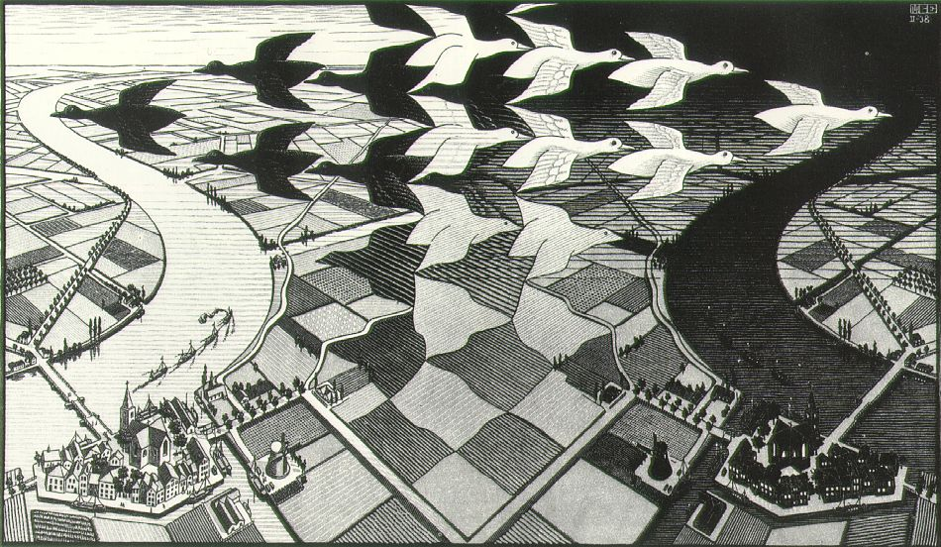

Day and Night, by Escher

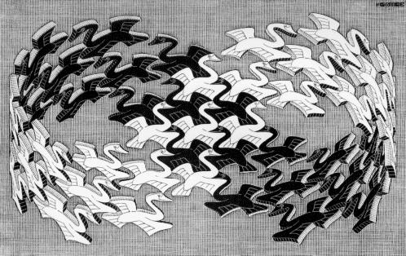

Swans, by Escher

Go here for more information about Escher’s art:

<http://www.pxleyes.com/blog/2010/06/recursion-the-art-and-ideas-behind-m-c-eschers-drawings/>

I’d love it if we could make something similar this, but if you violently object and suggest nicer options, I wouldn’t mind. The point I’m making is that Escher’s art is extremely clever and mind-blowing.

## City Design

Just a thought: if there are no cars in our city, then why should the roads look the way they do right now? I love the way the roads look. They’re awesome, but they make no sense in a world where there are no cars.

Here are some other ideas I came up with:

1. Mood-inspired Variations

Each district will have variations in architectural style depending on the mood of the district. (We’ve agreed to name districts according to mood, haven’t we?) For example, if a district is named Happy Town, its buildings will be brighter and newer and cuter, and if a district is named Anger Town, its buildings will be taller and older and more serious-looking and will probably have lots of graffiti.

1. Differing Building Heights

I think our buildings don’t all have to have the same height. Let’s make short buildings and tall buildings, just for variety.

1. Details

Billboards, foliage, manholes, chimneys (I have codes for implementing moving smoke by the way) anyone?

1. The Sky

Something’s wrong with how we’re drawing the sky; I just can’t put a finger on it yet.

## More Animation

A game just looks so much more fun to play if there’s a right amount of animation. Refer to the comment on *HopeBlocks* if necessary.

## Music and Sound Effects

Just because I love puns so much, all of the music I’ll be making will be in a light swing or jazz style. Lots of sound effects will have to be added too. Make suggestions on any special sounds you’d like to be present in the game.